**Island Sampling Day (ISD) Sampling Protocol**

Soil will be collected in 50 ml Falcon tubes, stored in dry-ice containing coolers during the sampling event, stored at -20 degrees C at HCMR and shipped overnight via FedEx to the US.

**Plant Barcoding at ISD**:

Additionally, at each sampling site, we will collect plant samples and take photos of each plant. HCMR will conduct the barcoding.

Specific plants have been identified for the majority of sampling sites, corresponding to geographically and elevation distinct flora of Crete. **At each site, soil will be collected from two adjacent locations**. The same type of plant will be selected for each sampling location. If this is not possible, teams should select (and document) the second plant type.

**We will collect 3 - 50 ml Falcon tubes of soil at each sampling location (i.e. plant)**

**Tube 1:** for metagenomic analysis

**Tube 2:** for soil chemistry analysis

**Tube 3:** for storage at HCMR

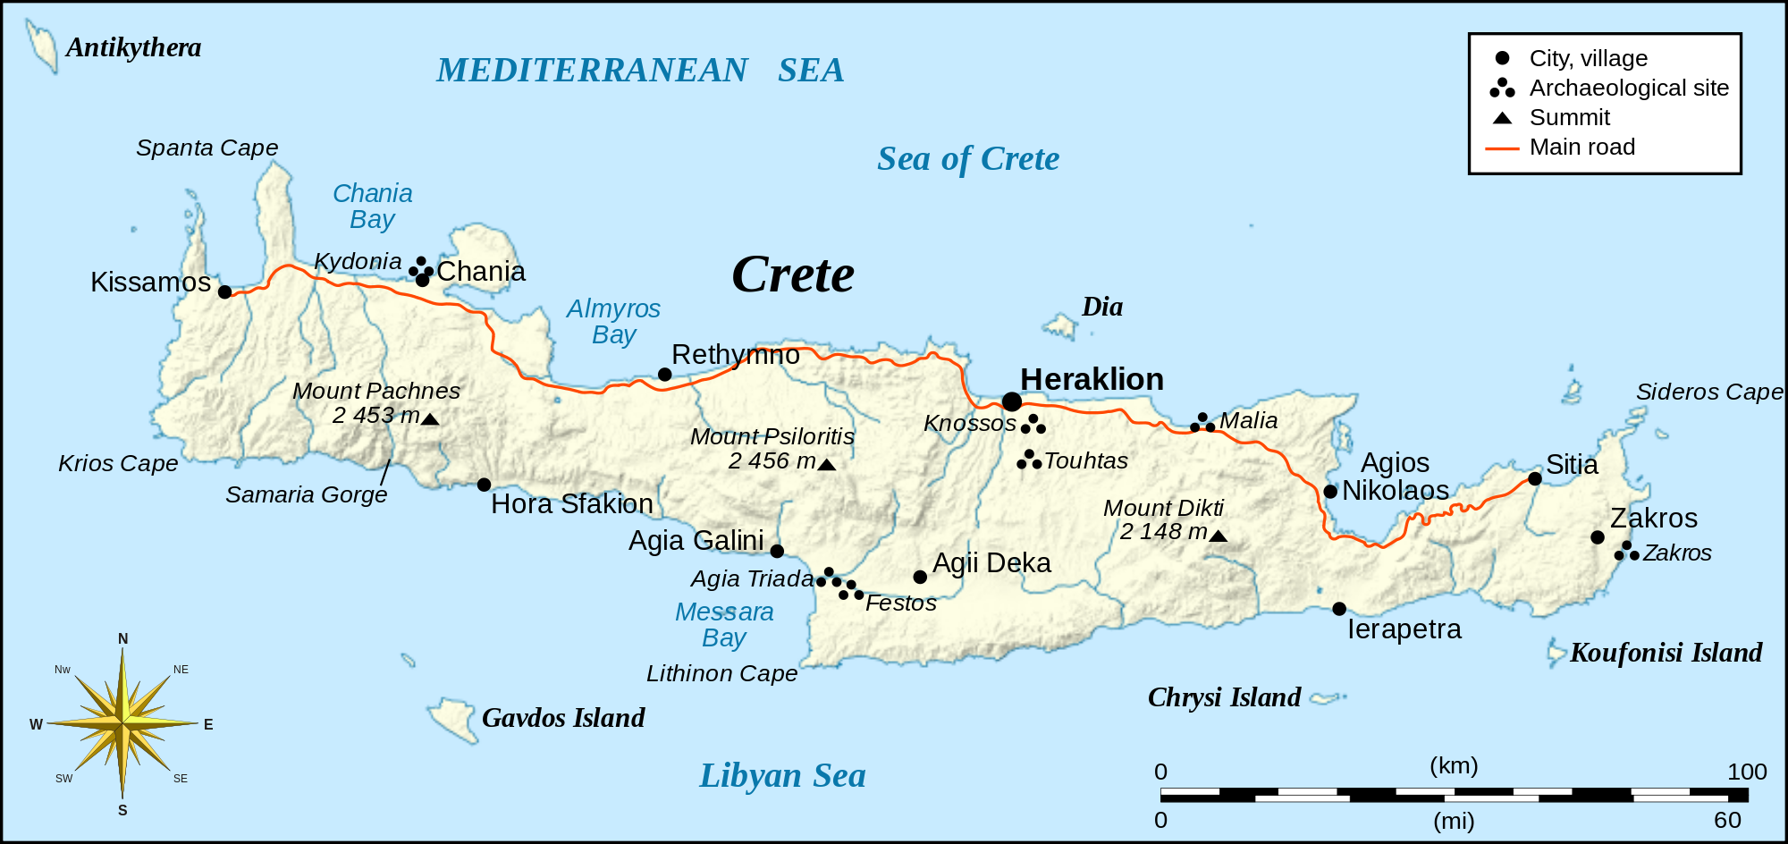

**Sampling Sites:**

Each team will be provided with a list of sampling sites and a map of their sampling route. Soil will collected for two metagenomic communities from each of 110 unique sampling sites.

**ISD** [**map**](https://www.google.com/maps/d/u/0/edit?mid=1ZZ3mzc7yr0X2Sn3o5FYCUHuApyY)

**Crete Vegetation Zones –** color code for ISD map

coastal and littoral zones (0-20 m);  — yellow

lowland (20-300 m);  —red

semi or sub-mountainous (300-800 m);  —green

mountainous (800-1800 m); — orange

sub alpine 1800-2200; —light blue

alpine (+2200 m)

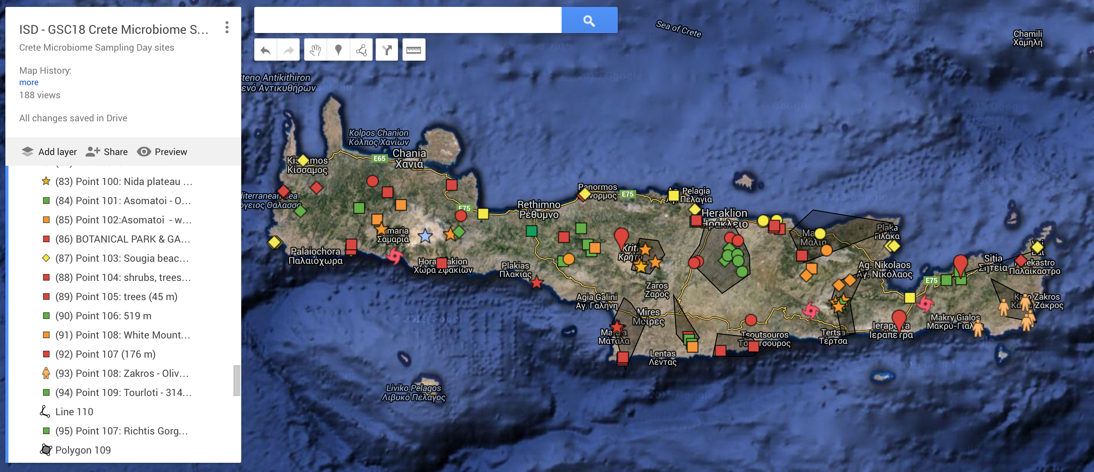

**example sites:**

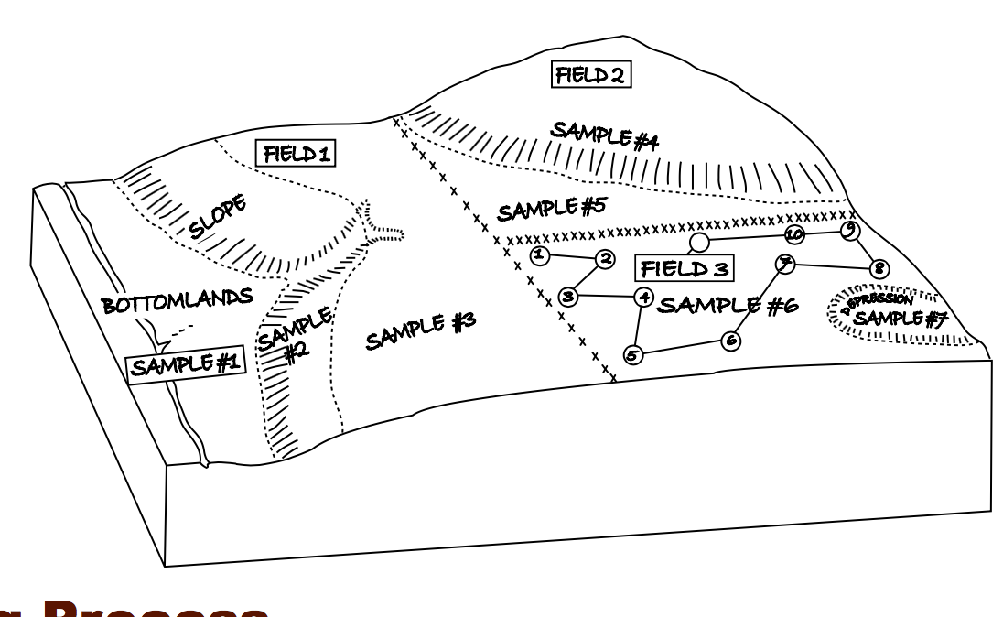

[USDA sampling soils](http://www.nrcs.usda.gov/Internet/FSE_DOCUMENTS/nrcs144p2_051273.pdf)

**Identifying your sampling site:**

**Steps:**

**1:** **drive to the defined sampling sites** GPS coordinates

**2:** **identify two locations of soil for sampling**, at least 10 feet from the edge of the road

* identify the specified plant associated with your sampling site
* the two sampling locations should be 5-10 feet (1.5-3 m) apart
* take a photo of each sampling site, include the plant in the photos

Note: For the sampling locations not specified by the type of flora, the

sampling team will select and identify the present flora.

**3: metadata collection**: (see below)

Metadata will be collected on a smart phone GIS cloud app & on a log sheet, the MetaSUB GIS cloud app has been adapted for ISD.

**MIxS soil metadata**: (collect on GIS cloud app & record on data sheet)

**Pre-filled in metadata:**

collection date: 2016-06-15

**environment biome:** terrestrial biome

**environment material**: soil

**sample collection method**: soil borer

**amount of sample collected**: 50 ml

**depth**: 0-10 cm

**elevation**: (identified by GPS coordinates)

**definitions:**

lacustrine beach:

A landform consisting of loose rock particles such as sand, gravel, shingle, pebbles, cobble, or even shell fragments along the shoreline of a lake.

-- lat_long will be recorded, when you submit this data

**Metadata to be filled in:**

**environment feature:**

agricultural land, alpine, beach, botanical garden, boulder field, cave, crevice, cultivated habitat, desert, farm, field, forest (e.g. oak forest), gravel field, grassland, greenhouse, lacustrine beach, meadow, national forest, nature reserve, olive grove, orchard, park, pasture, planted forest, plateau, sandy beach, valley, vineyard

sample number

collection time:

city (nearest town/city)

soil moisture (measurement, %)

soil temperature (°C)

pH

plant type

land use: agriculture, pristine, beach

occupancy: high, med, low, none

traffic: high, somewhat, little

place name

manual time entry (collection time)

land use:

cultivated, drylands, forest, inland water, mountains, urban

(skip all other fields)

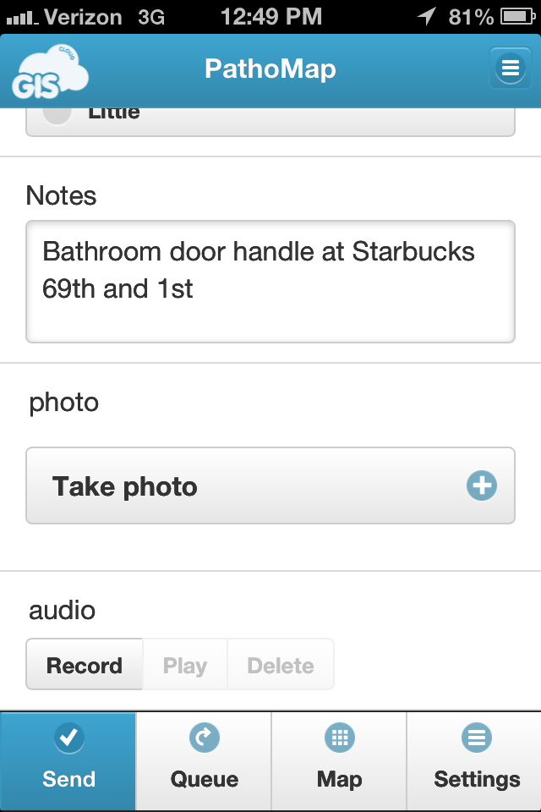[**Click on Send**] to submit the metadata to the cloud. While offline, data is stored to the app, when back online, the data will upload to the app.

4: **select an area of soil**, that is 2 feet (0.6 m) from the base of the tree/plant

* Take a photo of the soil
* Identify soil type:

Shale, conglomerates, clay deposits, limestone, limestone & flysch, mari, alluvial fan, flysch, clay, sandy clay, silty clay, clay loam

5. **labelling:** Sample ID is ISD_TeamNo(1-9)_SiteNo(1-14)_LocNo(1-2)_ReplicNo(1-3)

(1: DNA, 2:CHEM, 3:HCMR)

Write the sample ID on each tube, put 3 replicate tubes of each location in one plastic bag and write the ID without replicate No on the small piece of paper provided. Tie firmly the bag with a simple knot and place inside the dry ice container.

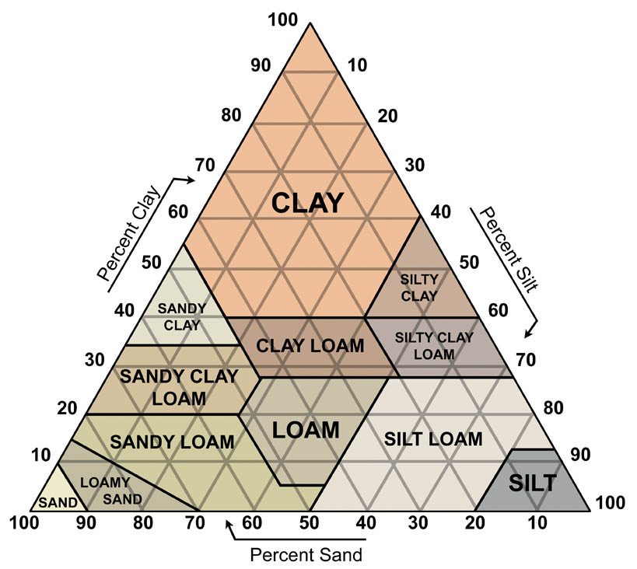

(http://www.soilsensor.com/soiltypes.aspx)

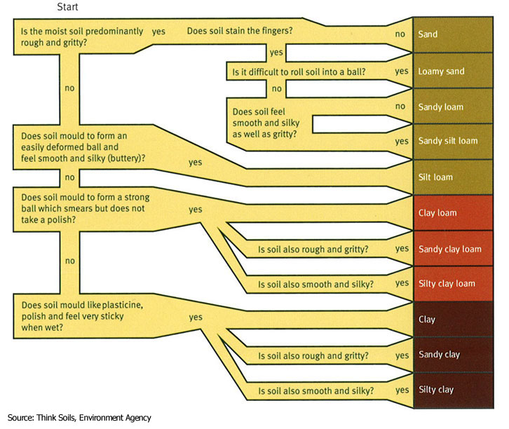

(<http://www.swarmhub.co.uk/sub_soils.php?id=2670>)

**5: pH, soil moisture and temperature measures**

* within the same area of soil (2 inches/ 6 cm – to the right of the spot where the soil will be sampled
* utilize the pH/soil moisture and thermometers into the soil, record readings

**6: sweep away any organic material** (e.g. leaves, seeds, branches) from the sampling location

**7: soil collection procedure** – total of 6 X 50 ml Falcon tubes per location

**materials:**

50 ml hydrogen peroxide/cleaning

60 Falcon tubes

plastic bags (put falcon tube (with soil) inside of plastic bag)

plastic bag for plant collection

dry ice

cooler

labels for

water

paper towels

pens

recording sheet

spoon

pH & moisture meter

thermometer

soil borer (3 particles)

- an aluminum tube ~15cm long, 2cm wide

- a ram

- a narrow tube with a plastic head for pushing the ram

**Procedure:**

-First clean the tube and the ram with water and paper to take away any dirt

- **soil borer cleaning** (prior to tube 1, metagenome sampling)

Spray the tube and the ram with hydrogen peroxide solution and leave for three minutes

- put the tube on the ground and the ram inside the tube and by using a stone or the plastic head as a hammer push the tube in the soil

- There are two marks (rings) on the tube (5cm-8cm) - A depth between these two marks is enough for collecting 40cc soil

- carefully take out the tube from the ground and put the lower edge inside the falcon tube (if the soil is dry, the soil could fall out)

- if sampling sand, scoop horizontally

-if you use the metal spoon, sterilize before using for tube #1: DNA

-use the narrow tube in order to push the ram down

**GIS Cloud App Instructions**

**Before Sampling**

1. Download the free app onto your smartphone. Search “GIS Cloud Mobile Data Collection” in the App Store.

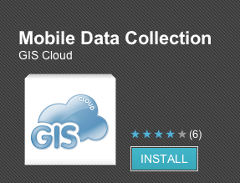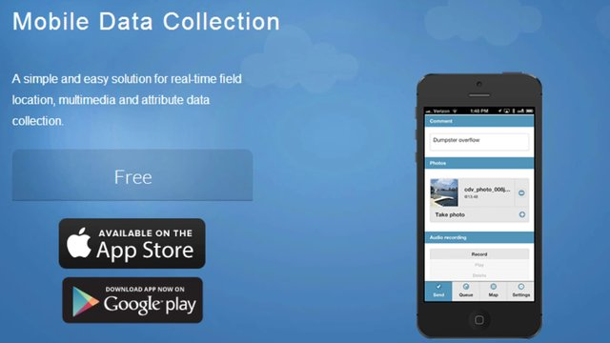

1. Log in:

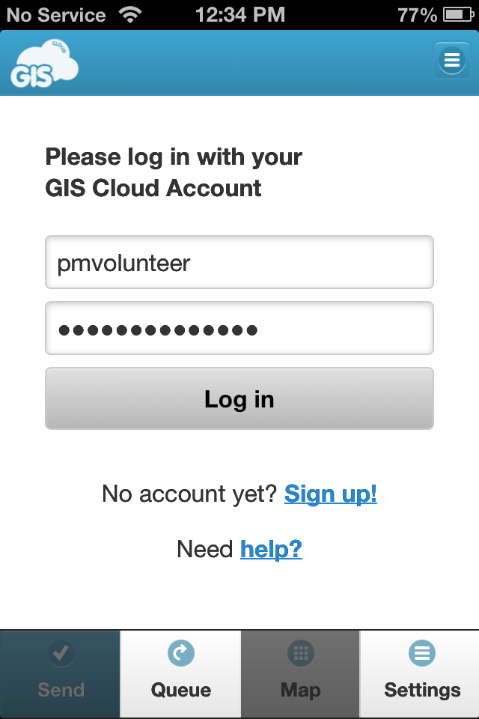

**Username: island.metasub**

**Password: masonlab1**

**Maps: island_layer**

View collected metadata:

<http://editor.giscloud.com/map/559654/islandlayer>